Capstone Project 1: Stats

Appliances Energy Prediction –

Business Problem Description – Dataset contains the house temperature and humidity conditions were monitored with a ZigBee wireless sensor network. As per the description on UCI website, each wireless node transmitted the temperature and humidity conditions around 3.3 min, then, the wireless data was averaged for 10 minutes periods. The energy data was logged every 10 minutes with m-bus energy meters. Combining this data with the weather data based on the date time columns

Link for the Jupyter file

- https://github.com/arijitsinha80/Springboard/blob/master/Project/Capstoneproject_Phase2.ipynb

From the Data Wrangling activity, we created the input.csv as the final dataset. This has 19735 observations and 30 attributes.

Divide the data in dimension wise to explore from the input dataset –

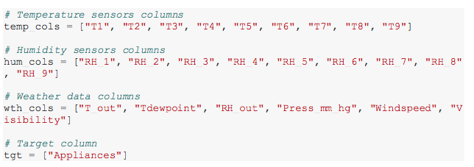

From the above dimensions, we will start to explore data for each – Plot the scatter matrix for Temperature attributes using method “ diagonal="kde"

Plot the scatter matrix for Temperature attributes using method “ diagonal="kde"
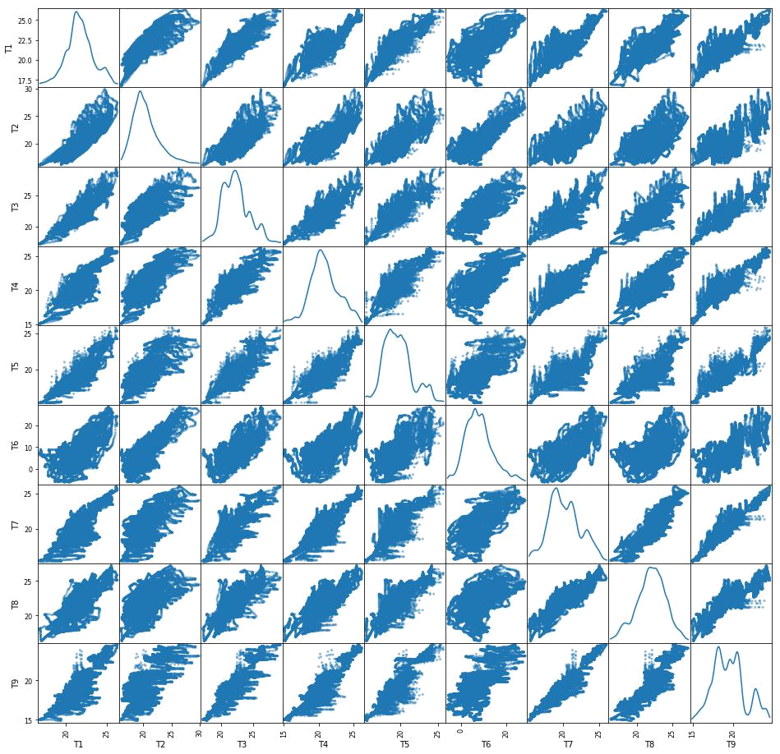

- From the above figure, we can see that there is some linear relation between T7 and T9. Others are having the shape but are not exactly linear.

- There is a relation between these two attributes but also have some outliers
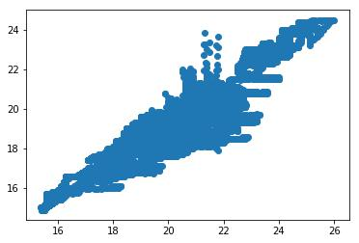

T6 and T_out is highly correlated, T6 is from the outside the house reading and T_out is the data collected from weather's site
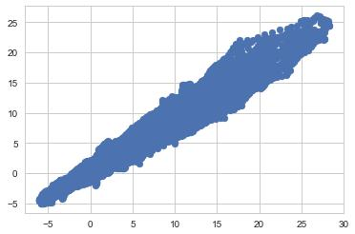

Explore the data using the Weather Dimension -
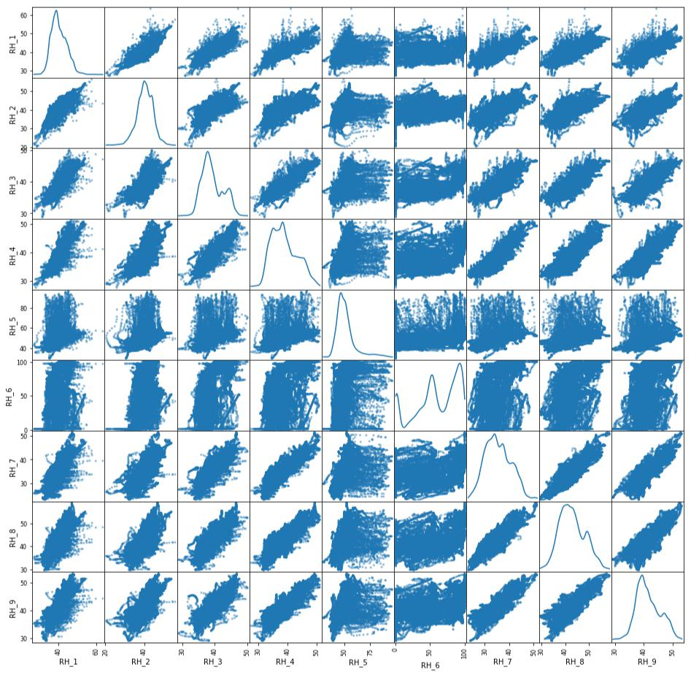

- There doesn’t seems to be having any linearity between any of the attributes.

Lets explore the distribution using the histogram –
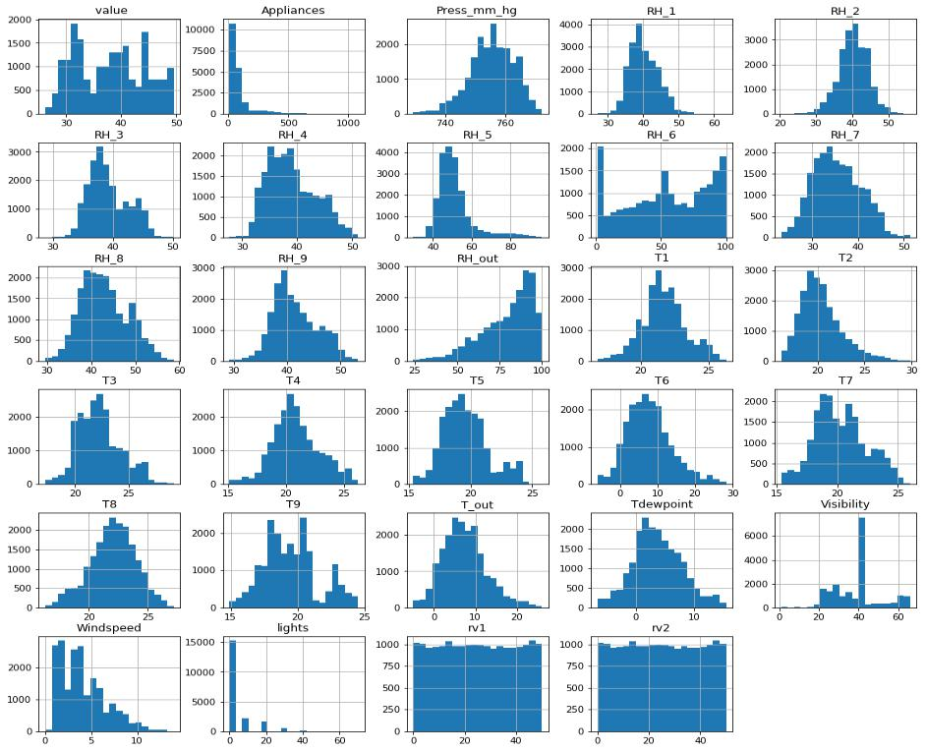

- All humidity values are almost having normal distribution except RH_6 and RH_out. In other words the reading from inside the home is having normal distribution.

- All temperature readings follow a Normal distribution except for T9.

- Visibility, Windspeed and Appliances are having skewed data.

- Rv1 and Rv2 are random variables and doesn’t seems to be contributing

On the Target Attribute – Appliance, the below histograms is rightly skewed and most of the data is with 200 KWh.
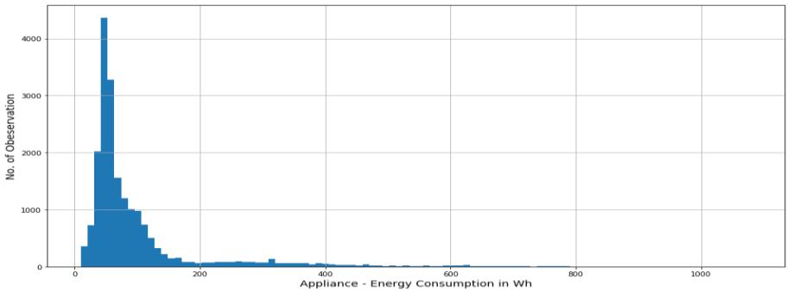
Target variable, Appliances is highly right skewed.
Alternatively exploring using Boxplot – on Appliance Attribute
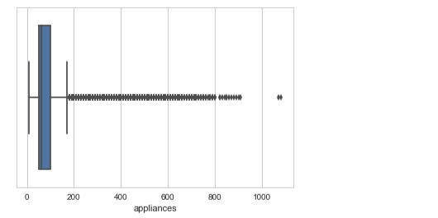

- Percentage of dataset in range of 0-200 KWh is 90.291%

Using the date attributes, created new columns for Month and Weeks using the datetimestamp method

With taking the average on week – Monday the usage has been higher, followed by Saturday and Friday.
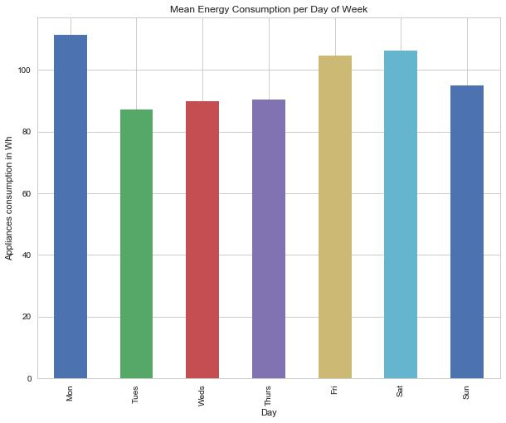

For Monthly Average – On a average, February and April the consumption has been more than other months.
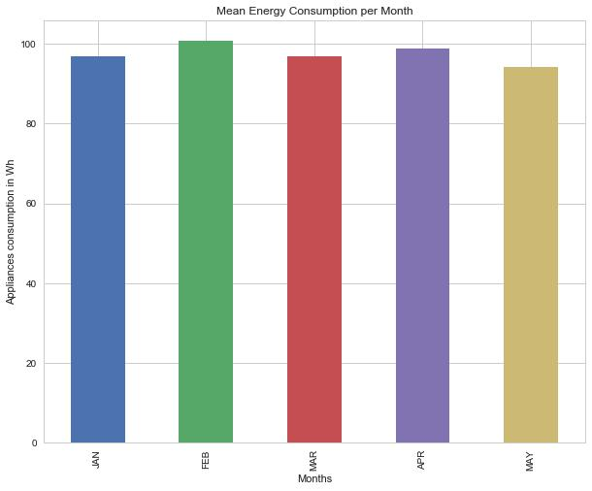

For Day wise consumption – plotting this date wise, energy consumption, In January month there were 2 days when the consumption was more than 1000 KWh.
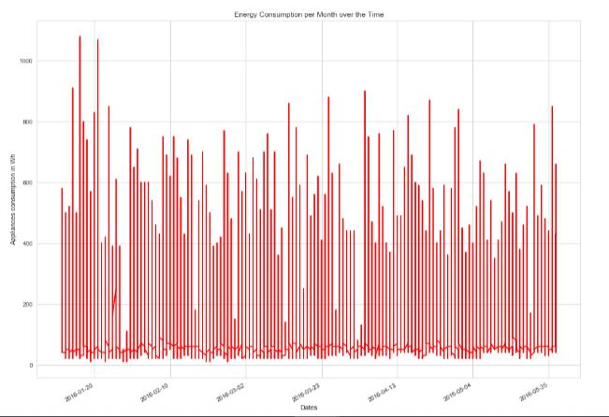

Since the Appliance data captured were rightly skewed, converting the column to Log values to see if it has the normal distribution.
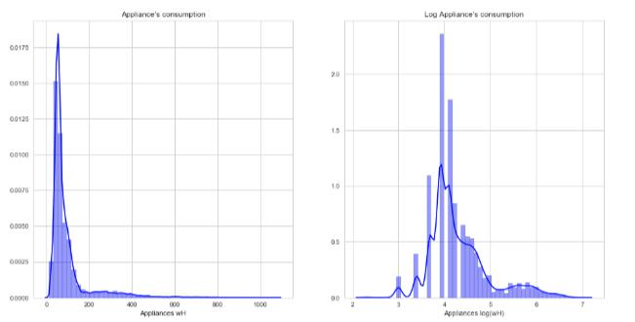

Let’s explore the Correlation plot –

With Appliance attribute –
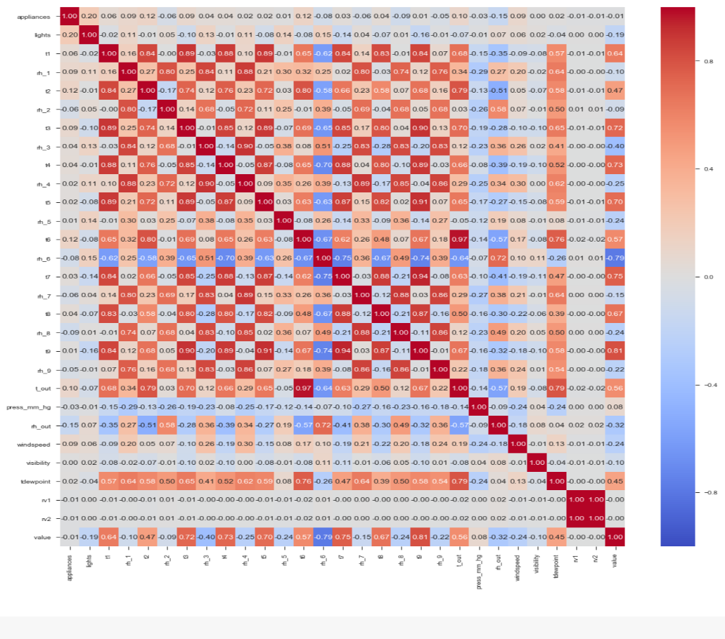
Scatterplot between appliances and t2
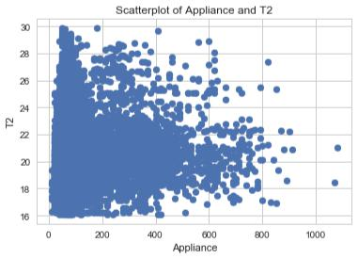

Scatter plot between Appliance and Lights
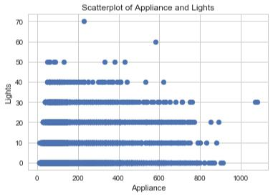

Scatterplot between Appliance and T6
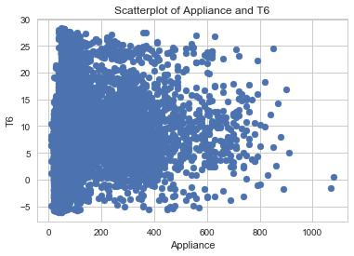
Scatterplot between Appliance and T_out
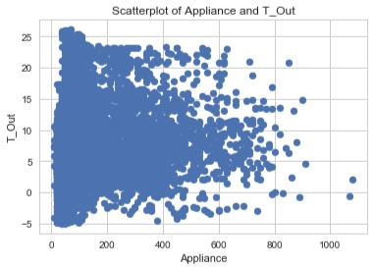

Correlation plot of using Log value of Appliance -
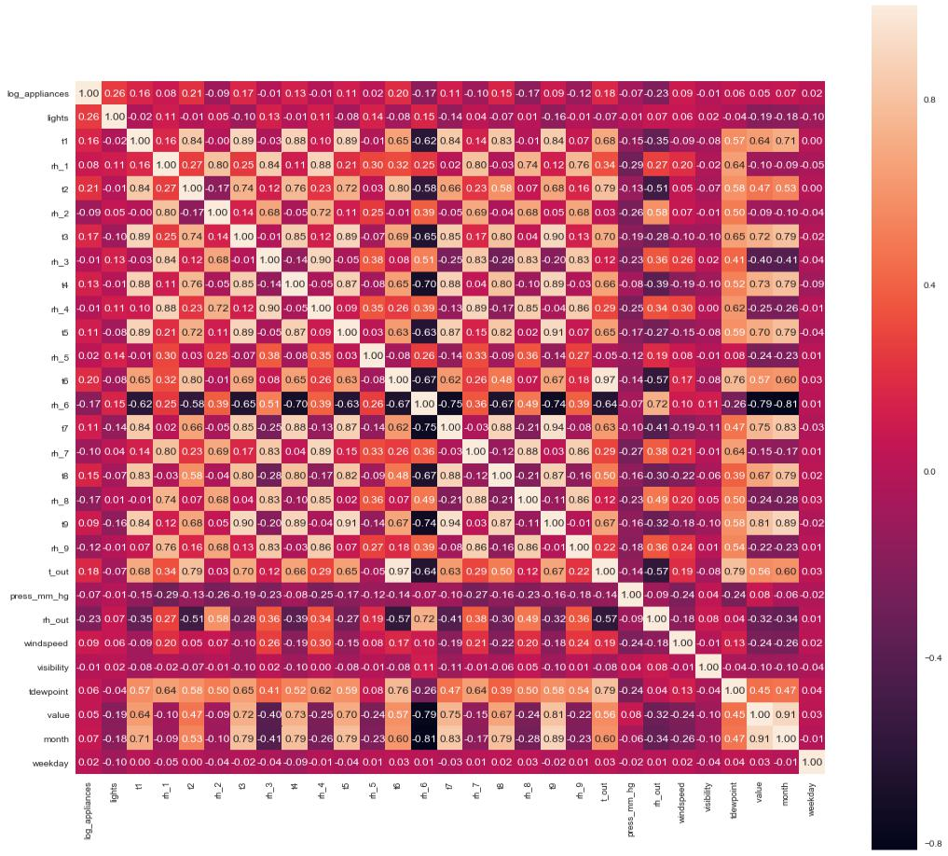
With Log Appliance

- The most correlated features with energy consumption(log_appliances) are: lights=0.26, t6=0.20, t2=0.22, t3 = 0.17,t_out = 0.18, rh_out = -0.23, rh_8 = -0.17, rh_6 = -0.17, windspeed = 0.09.

- In a linear regression problem only linear independent variables can be be used as features to explain energy consumption otherwise we will have multicollinearity issues.

Scatter plot of log_appliance and t1
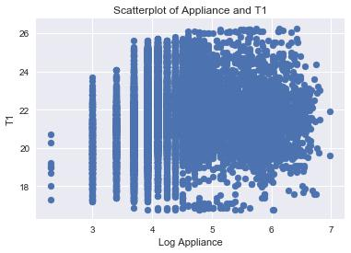

Scatterplot between log_appliance and lights
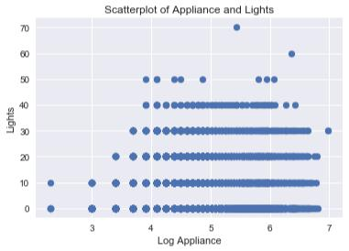

Scatter plot between log appliance and t_out

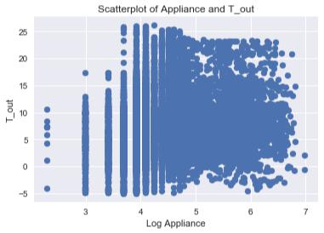

Variables that are particularly significant in terms of predicting Appliance Energy Consumption based on the correlation matrix –

- Between Appliance and Lights

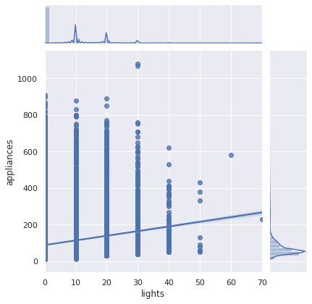

- Between Appliance and Windspeed

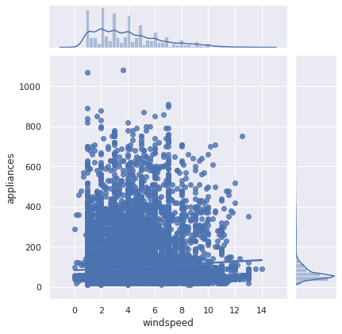

- Between Appliance and T6

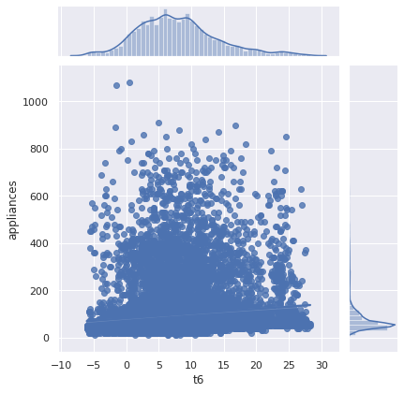

- Between Appliance and T2

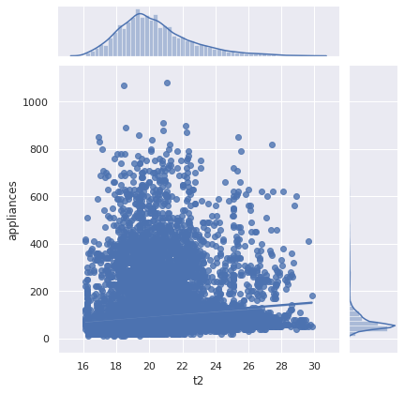
- Between Appliance and T3
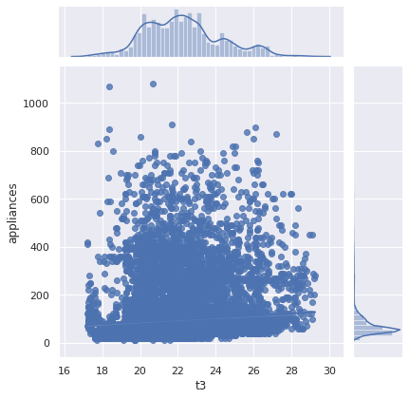

Calculate the Correlation between Temperature features -

- Correlation between T9 and T1 pearson 0.84 0.00 None
- Correlation between T9 and T2 pearson 0.68 0.00 None
- Correlation between T9 and T3 pearson 0.90 0.00 None
- Correlation between T9 and T4 pearson 0.89 0.00 None
- Correlation between T9 and T5 pearson 0.91 0.00 None
- Correlation between T9 and T6 pearson 0.67 0.00 None
- Correlation between T9 and T7 pearson 0.94 0.00 None
- Correlation between T9 and T8 pearson 0.87 0.00 None

Check, if the Temperature, Humidity and Weather features influences Appliance –

1. Coefficient table (middle table). We can interpret the t3 coefficient (4.3471) by first noticing that the p-value (under P>|t|) is so small, basically zero. This means that the t3 is a statisticall significant predictor of appliance energy consumption.
The regression coefficient for t3 of 4.3471 means that on average, each additional t3 temperature is associated with an increase the appliance energy consumption
The confidence interval gives us a range of plausible values for this average change, about (3.637 and 5.058)
R^2 is only 0.007, hence t3 doesn't contribute much on the variance. F-Statistic The F-Statistic is 143.8 and the probability for this statistic is 5.09e-33, which is close to 0. We can safely reject the null hypothesis, indicating that at least one 𝛽 coefficient is nonzero.
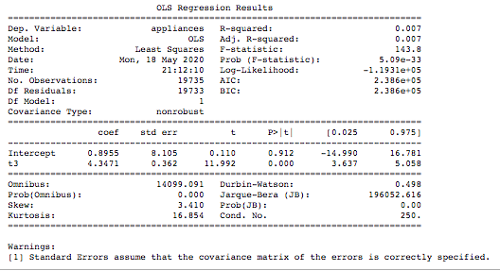

2. Coefficient table (middle table). We can interpret the t3+t6 coefficient (0.4119, 1.8871) by first noticing that the p-value (under P>|t|) is so small, basically zero. This means that the t6 is a statisticall significant predictor of appliance energy consumption.
The regression coefficient for t6 of 1.8871, means that on average, each additional t6 temperature is associated with an increase the appliance energy consumption
The confidence interval gives us a range of plausible values for this average change, about (1.566 and 2.208)
R^2 is only 0.014, hence t3 and t6 doesn't contribute much on the variance. F-Statistic The F-Statistic is 138.8 and the probability for this statistic is 1.39e-60, which is close to 0. We can safely reject the null hypothesis, indicating that at least one 𝛽 coefficient is nonzero.
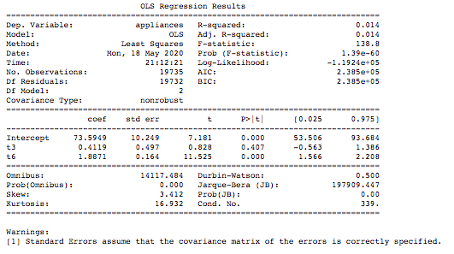

3. Coefficient table (middle table). We can interpret the t3+t6+rh_out coefficient (1.8057, 0.3079, -0.9076) by first noticing that the p-value (under P>|t|) is so small, basically zero. This means that the t6 is a statistical significant predictor of appliance energy consumption.
The regression coefficient for rh_out of -0.9076, means that on average, each additional t6 temperature is associated with an decrease the appliance energy consumption
The confidence interval gives us a range of plausible values for this average change, about (-1.025 and -0.790)
R^2 is only 0.025 better than previous, hence t3, t6 and rh_out doesn't contribute much on the variance. F-Statistic The F-Statistic is 170.3 and the probability for this statistic is 4.96e-109, which is close to 0. We can safely reject the null hypothesis, indicating that at least one 𝛽 coefficient is nonzero.
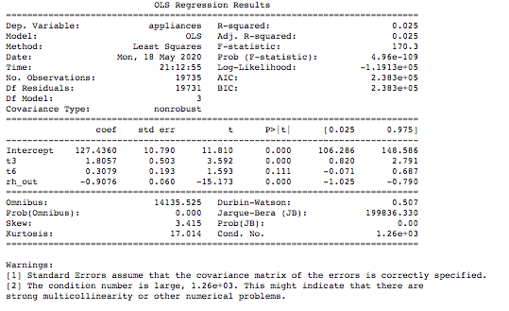
4. Coefficient table (middle table). We can interpret the t1+t2+t3+t4+t5+t6+t7+t8+rh_1+rh_2+windspeed, coefficient (9.0446, -25.6614, 17.7293,-1.4768,-7.3830,-7.5650,1.0356,-6.2685,9.4475,20.0347,-20.3286,1.6784) by first noticing that the p-value (under P>|t|) is so small, basically zero. This means that the t6 is a statisticall significant predictor of appliance energy consumption.
The confidence interval of t3 gives us a range of plausible values for this average change, about (15.814 and 19.644)
R^2 is only 0.098 better than previous, F-Statistic The F-Statistic is 194.5 and the probability for this statistic is 0. We can safely reject the null hypothesis, indicating that at least one 𝛽 coefficient is nonzero.
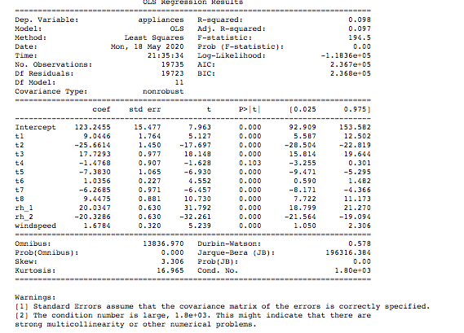
Pairplot for 't6','t2', 'rh_2','lights','t_out','windspeed','tdewpoint' features for their distribution –
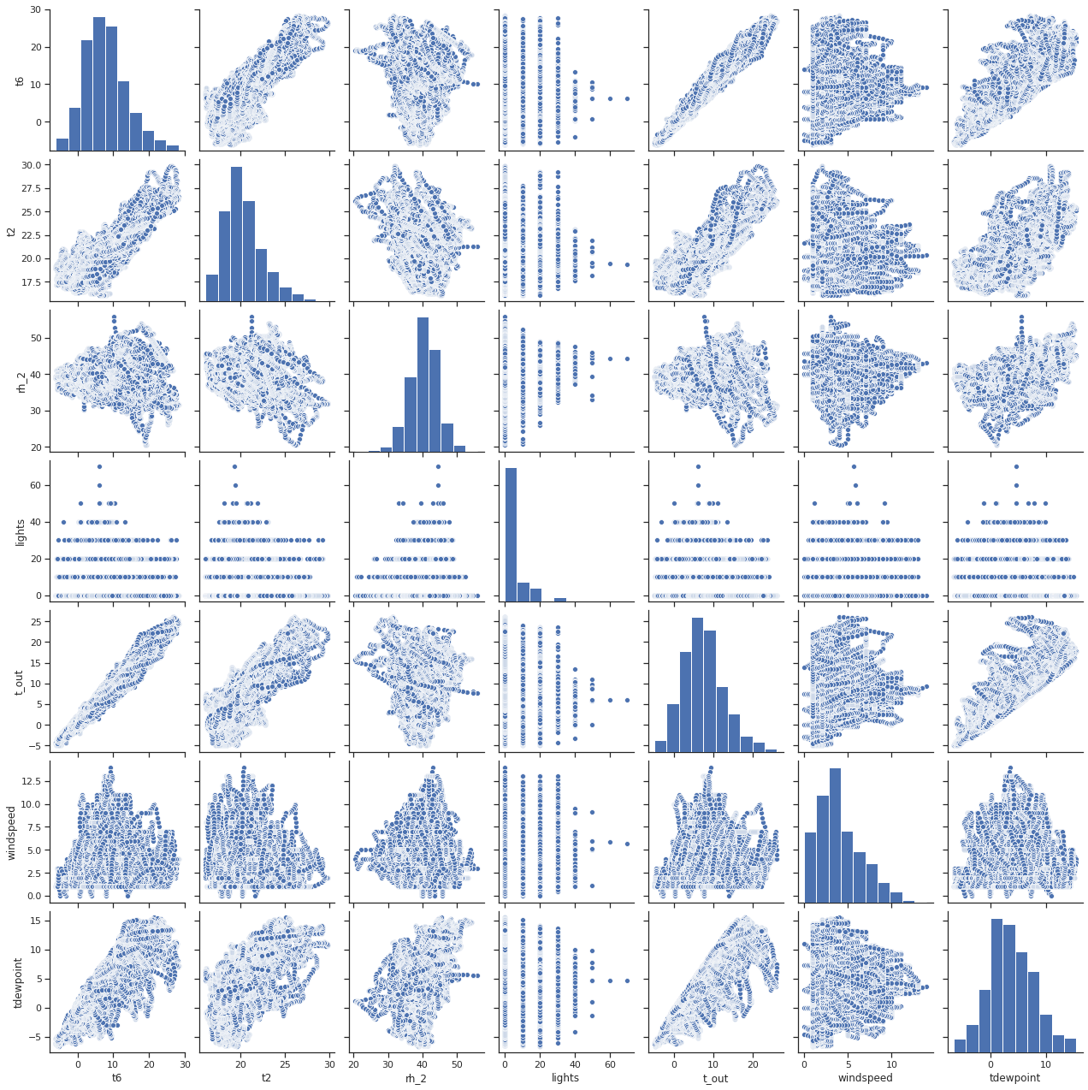

Is there a significant difference between T6 and T_out and impact my future Prediction Models –
With Description and plotting the jointplot of the two features -
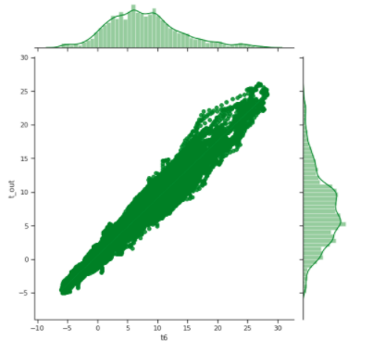

Run a Two-sided T-test with the following hypotheses:
Null hypothesis: t6 = t_out
Alternate hypothesis: t6 != t_out
Upon Conducting the T-Test – received the below values - Ttest_indResult(statistic=8.675177895656354, pvalue=4.283728402821399e-18)

Result - Given the high p-value: 4.2, hence will not reject the null hypothesis that feature t6 and t_out almost same and redundant.

